Password Authentication For Prometheus:

1. Follow the article below and create web.yaml as shown in below url.

<https://prometheus.io/docs/guides/basic-auth/>

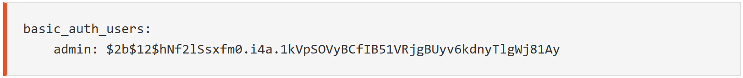

1. Update the /etc/systemd/system/prometheus.service as below and make sure you copy web.yml file to location /etc/systemd/system/web.yml

[Service]

User=prometheus

Group=prometheus

Type=simple

ExecStart=/usr/local/bin/prometheus \

--config.file=/etc/prometheus/prometheus.yml \

--storage.tsdb.path=/var/lib/prometheus/ \

--web.console.templates=/etc/prometheus/consoles \

--web.console.libraries=/etc/prometheus/console_libraries \

--web.enable-lifecycle \

--web.enable-admin-api \

--web.config.file=/etc/systemd/system/web.yml \

--log.level=info

[Install]

WantedBy=multi-user.target

1. sudo systemctl daemon-reload && sudo systemctl restart prometheus && sudo systemctl status prometheus
2. nano /etc/systemd/system/web.yml

basic_auth_users:

admin: $2b$12$hNf2lSsxfm0.i4a.1kVpSOVyBCfIB51VRjgBUyv6kdnyTlgWj81Ay

tls_server_config:

cert_file: /etc/prometheus/certs/awsb43.xyz/awsb43.xyz.crt

key_file: /etc/prometheus/certs/awsb43.xyz/awsb43.xyz.key

User ID: admin

Password: test

